1905387

CHAUDHARY HAMDAN

ALGO LAB 1

Date : 09-07-2021

Q1.

WAP in C to input n integers in to an array. Let us assume that there can be duplicates elements. Write a program to search an element in the array in such a way that we get the highest frequency if there are duplicate elements.

Code:

#include<stdio.h>

int main() {

int n;

scanf("%d", &n);

int arr[n], arr2[n];

for (int i = 0; i < n; i++) {

scanf("%d", (arr + i));

arr2[i] = arr[i];

}

int freq = 0;

for (int i = 0; i < n; i++) {

int c = 1;

if (arr[i] != -1) {

for (int j = i + 1; j < n; j++) {

if (arr[i] == arr[j]) {

arr[j] = -1;

c++;

}

}

if (c > freq) {

freq = c;

}

}

}

printf("%d\n", freq);

for (int i = 0; i < n; i++) {

int c = 0;

for (int j = i; j < n; j++) {

if (arr2[i] == arr2[j]) {

c++;

}

}

if (c == freq) {

printf("Number with highest frequency: %d with count = %d\n", arr[i], freq);

}

}

return 0;

}

Output:

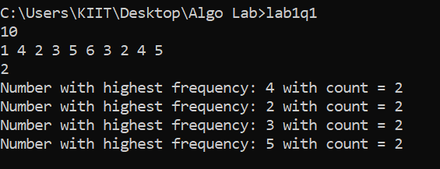

Q2.

WAP for finding i and j in an array A for any key such that A[j]2 + A[i]2 == key.

Code:

#include<stdio.h>

int main() {

int n;

scanf("%d", &n);

int arr[n];

for (int i = 0; i < n; i++) {

scanf("%d", (arr + i));

}

int key, flag = 1;

scanf("%d", &key);

for (int i = 0; i < n; i++) {

for (int j = i + 1; j < n; j++) {

int a = arr[i] \* arr[i] + arr[j] \* arr[j];

if (a == key) {

flag = 0;

printf("Pair : %d, %d\n", arr[i], arr[j]);

}

}

}

if (flag) {

printf("No pairs found\n");

}

return 0;

}

Output:

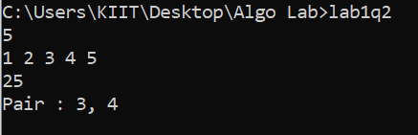

Q3.

Suppose an array A has n distinct integers. Increasing sequence is given as A[0].........A[k] and decreasing sequence is given as A[k+1]........A[n-1]. Write a program for finding k.

Code:

#include<stdio.h>

int main() {

int n;

scanf("%d", &n);

int arr[n];

for (int i = 0; i < n; i++) {

scanf("%d", (arr + i));

if (i && (arr[i] < arr[i - 1])) {

printf("Index : %d", (i - 1));

break;

}

}

return 0;

}

Output:

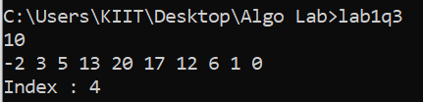

Q4.

WAP to display an array of n integers (n>1) in O(n) time, where at every index of the array should contain the product of all elements in the array except the element at the given index. No additional array declaration is allowed.

*Example:* Input : 10, 4, 1, 6, 2

Output : 48,120,480,80,240

Code:

#include<stdio.h>

int main() {

int n, tot = 1;

scanf("%d", &n);

int arr[n];

for (int i = 0; i < n; i++) {

scanf("%d", (arr + i));

tot \*= arr[i];

}

for (int i = 0; i < n - 1; i++) {

printf("%d, ", tot / arr[i]);

}

printf("%d\n", tot / arr[n - 1]);

return 0;

}

Output:

